**Name:** Bhavani Manthena

**How to compile and execute the code---**

Name of the program: AI1.py

Version of python: python 2.7.6

The code will be executed if you open it in notepad++ and run command (python AI1.py) in putty or SSH.

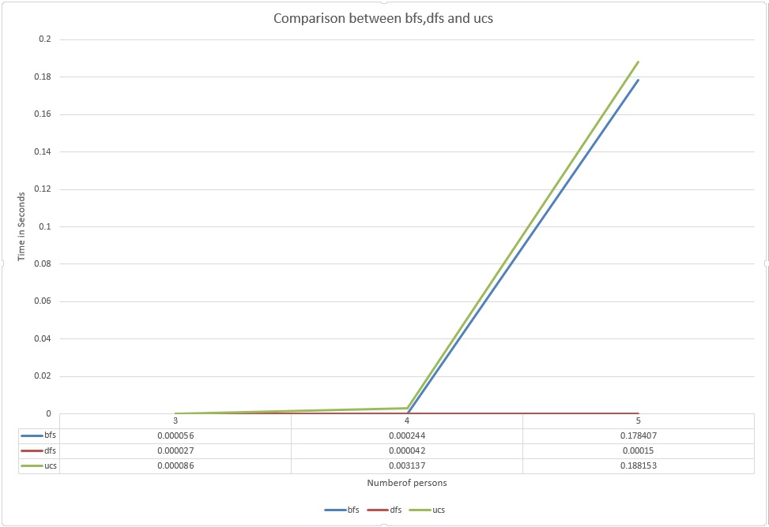**Description**: As you run the program the program asks for number of persons to cross the bridge and then it generates numbers randomly and executes bfs,dfs and ucs and gives the time in seconds.

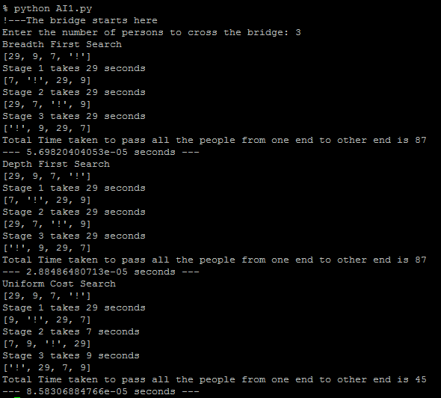Screenshot for the program execution: